**How to Use LabelImg**

Labelme is an open-source annotation tool. It was written in Python to support manual image polygonal annotation for object detection, classification, and segmentation. Labelme lets you create various shapes, including polygons, circles, rectangles, lines, line strips, and points. it also automatically saves the XML files of your labeled images.

1. To use the LabelImg tool you need to download it from the Git hub Repository as shown below.

URL: <https://github.com/heartexlabs/labelImg>

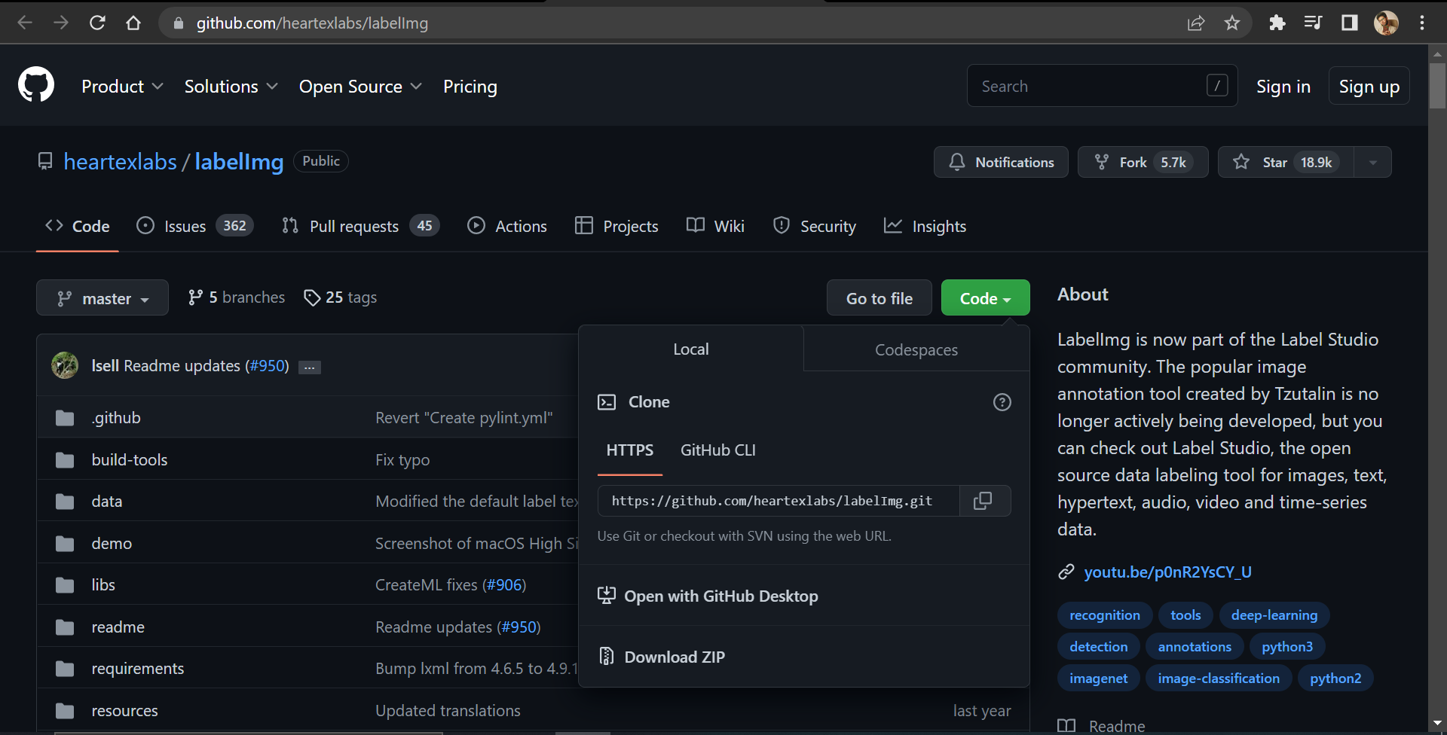

Click on the Code and you will see the option Download ZIP. You need to download the file and extract the file.

1. Open Anaconda prompt & change to the file directory

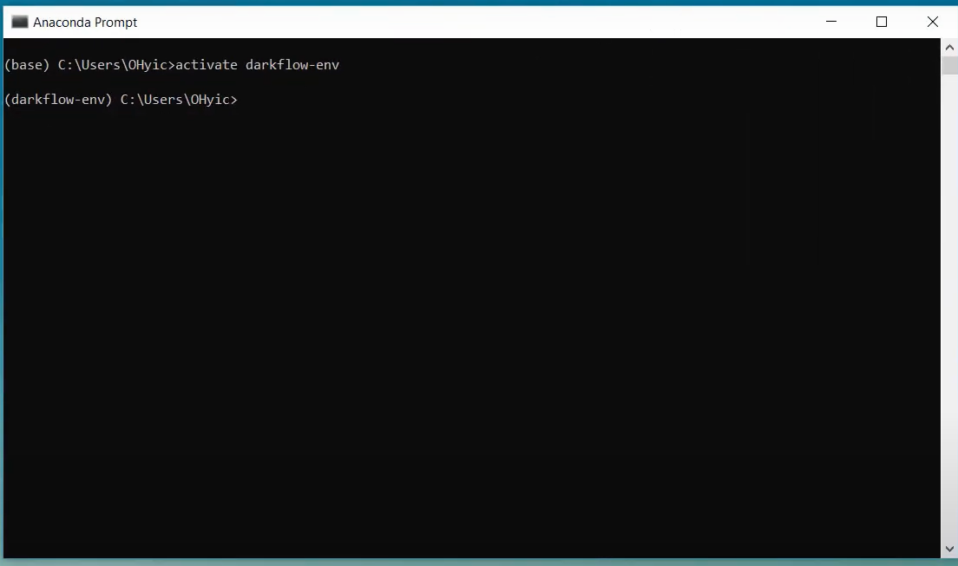

And you need to install the below resources.

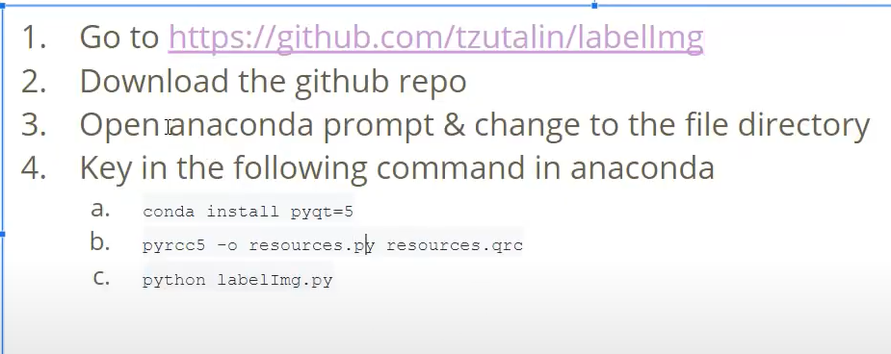

1. After installing the resources, you can run the command “python LabelImg.py” to open the Labelmg tool.

1. You can download any food item you desire here we are downloading **oranges** and labeling them. Once you opened the LabelImg you can open your downloaded files using the “**Open Dir**” option.

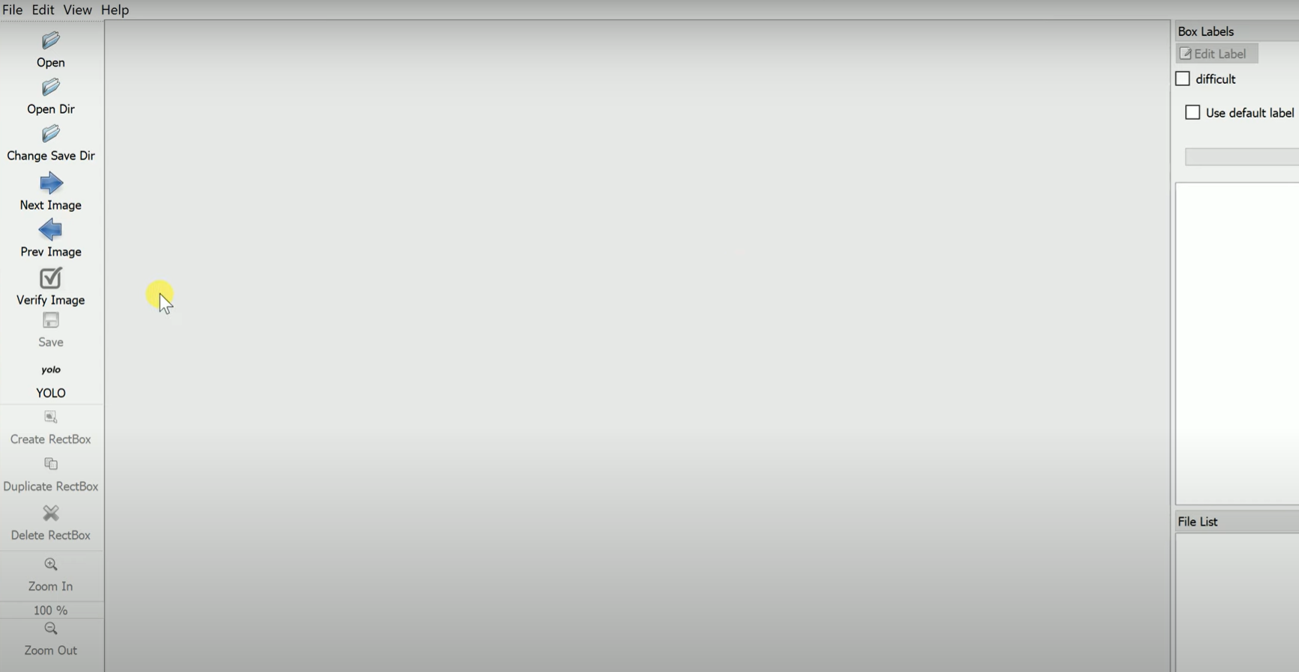

1. After that you can upload the image and annotate the image using bounding Boxes. And name it.

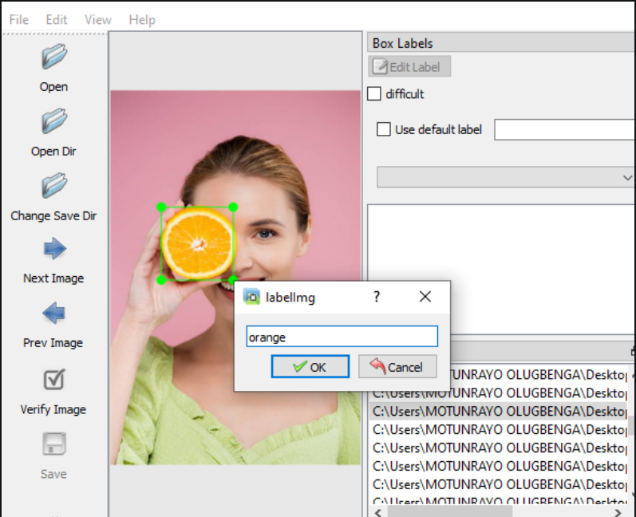

1. The main thing to remember in LabelIMg is that we **only use PASCAL VOC for annotation**. LabelImg saves annotations in the form of XML files in PASCAL VOC format and allows storage in multiple formats like YOLO and CreateML. Supporting these formats generally used in object detection pipelines make it a useful tool for annotating data for object detection.

1. While saving the images both the XML file and the download image should consist of the same name. This prevents corrupt XML files. These are the steps you need to follow while imaging annotation. If you face any difficulties while installing LabelImg you can go through this video <https://youtu.be/VsZvT69Ssbs>